tesylate
EXAMPLE QUOTATION / Q-0141

A better place to do your best work.
Riverside workspace · Prepared for Ashford Interiors
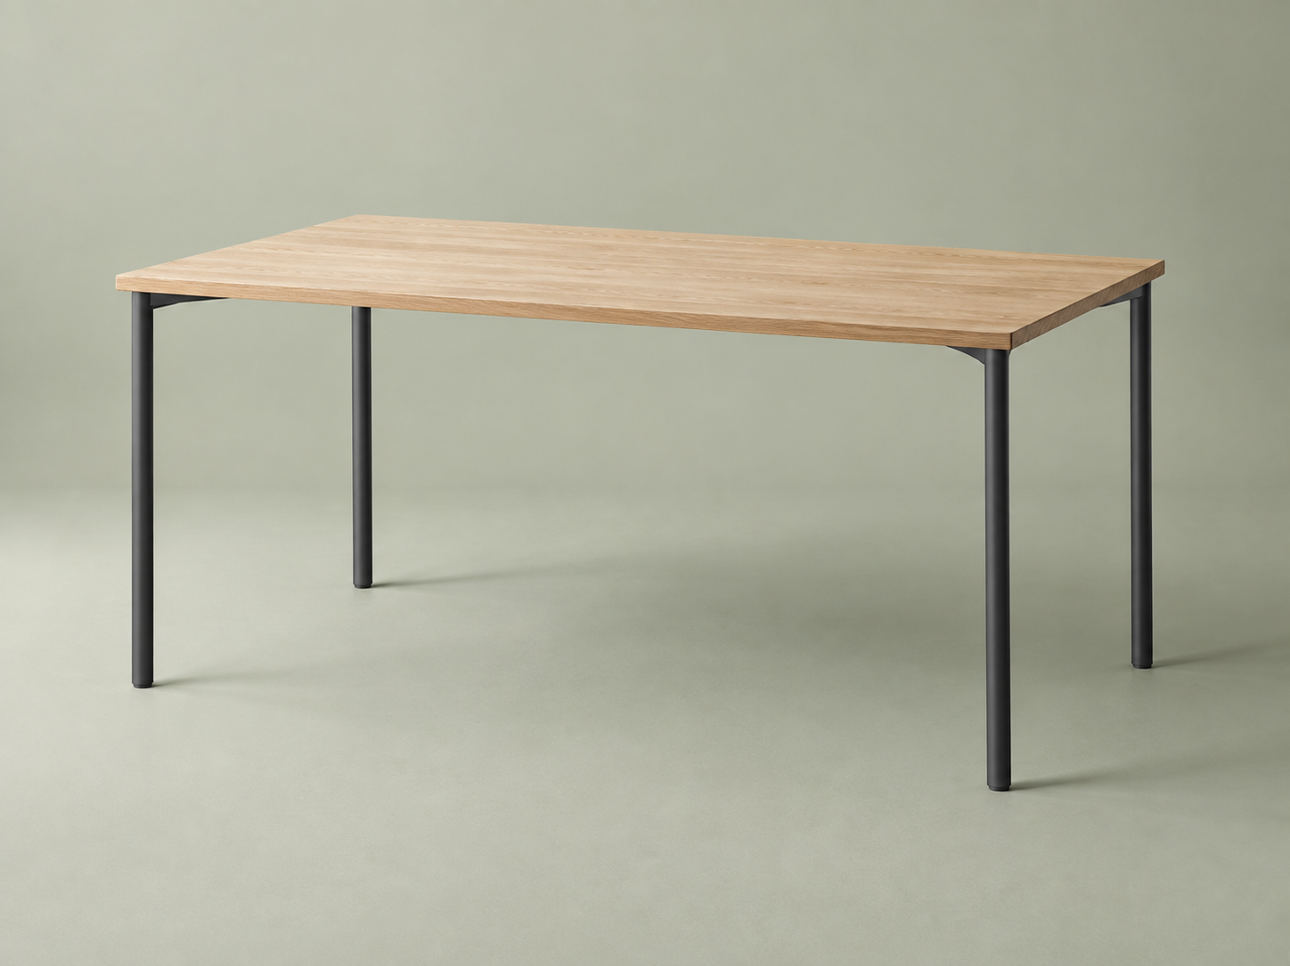
Description | Quantity | Unit price | Total
Studio desk · oak finish | 6 | £480 | £2,880
Total excluding VAT: £2,880
Illustrative document using sample records. This is not an offer for sale.

